**Prepared by: Fook Yen Edwin Chan**

**Topic –** CSS

**Topics Needed –** background-color, font-size, text-align, CSS for only class tag, font-family, display, margin, width, opacity, border-style, border-width, border-color, -webkit-filter, filter, outline-style, outline-color, outline-width, padding-top, padding-right, padding-bottom, padding-left,-webkit-transform:scaleX, transform, font-weight,margin-left

**Title –** Wonders of the World!

**Description –** This program will give you an opportunity to use many of the basic CSS tags that are used in nearly every web page. The basic webpage, wonders.html is provided for you. Try to create CSS file and name it **wonders.css**. Try to make the page look as similar as possible to the provided screenshot. Feel free to try out different CSS tags and experiment with different attributes from different tags!

**Step-by-Step Instructions**

1. Open the html file **wonders.html** in the same directory as all of the images.
2. Add the following line to right below the Title tag:

*<link rel = "stylesheet" type = "text/css" href = "wonders.css"/>*

1. Create a css file **wonders.css** in the same directory.
2. Now, lets try to make the background of the page blue! In **wonders.css**, create a css schematic for body, like as following:

body {

}

1. Inside the curly braces, set the attribute **background-color** as **#FF9009**.
2. Now, let’s try to adjust the font and position of all contents within h1 tags in the html! To do that , create a h1 CSS scheme, and set **font-size** as **40px, text-align** as **center.**
3. To make it less dull, let’s change the color of the heading! In the h1 CSS scheme, set **color** as **blue**.
4. Now, the words in the introduction looks too small. Now look into the html file. Do you see that there is a “class="intro" “ in the <h3> tag? That is called a class tag! Declare a schematic for such a class by the following:

**.intro{**

**}**

Try to make the words larger by creating a CSS scheme for the class and set **font-size** to **20px.**

1. Now, add “wonder” class tags to the <h2> tags with the names of the wonders in it and set **text-align** attribute to **center.**
2. Now let’s try to change the font of the paragraph. In order to do it, in the CSS scheme for p tag, set **font-family** to **sans-serif.**
3. Now, let’s position the images better! In order to do so, create a CSS schematic for img tag, and set **display** attribute to **block** and **margin** to **auto.** Also set **width** to **50%** See what happens!
4. Now, let’s make the images more opaque. In order to do this, in img schematic,set the **opacity** attribute to **0.8.**
5. Now let’s try to add borders to our **paragraphs**! In order to do that, set **border-style** to **double.**
6. It seems like the border is not wide enough. Let’s set **border-width** as **5px.**
7. It seems like the color of the border is not matching the background. Let’s set **border-color**  as **yellow.**
8. Let’s try to add filter to images! In order to do so, set **–webkit-filter** attributeto

**saturate(2)**  and **filter** to **saturate(2).**

1. Let’s add a frame/outline to the webpage! In order to do so, in body scheme, set **outline-style** as **solid** and **outline-color** to **red.** If you want to set the outline-width, you can set **outline-width** element to **a certain px, say 10px.**
2. It seems like there should be more room within the frames. In order to do so, in p scheme, set **padding-top** to **50px, padding-right** to **30px, padding-bottom** to **50px,** and **padding-left** to **80px.**
3. Now let’s get to some more advanced CSS with img tag! In order to make the image responsive, lets use webkit and use pseudo-classes to make the images reactive! Declare a pseudo-class of img as the following: img:hover {} and inside the scheme do the following:

**-webkit-transform: scaleX(-1);**

**transform: scaleX(-1);**

Now try to hover your mouse over the image to see the magic!

1. Now try to make the words in the paragraphs bold(tips: use **font-weight**).
2. Since the words “Location” and the year when the wonder is built is too close to the left, we want it to be further away. Please set the **margin-left** attribute to **50px** away from the left and set **padding** to **15px.** Also set **list-style-type** to **circle**.

This is the end of the assignment

**Screenshot**

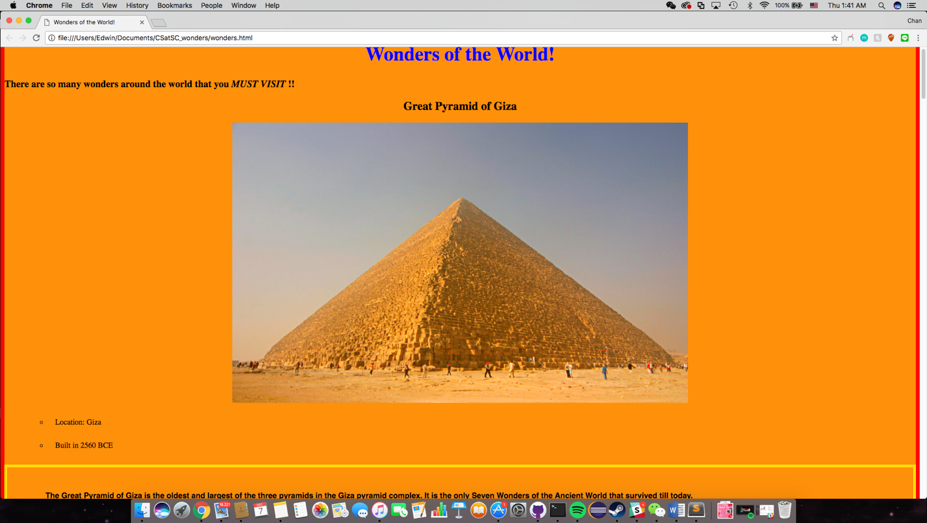

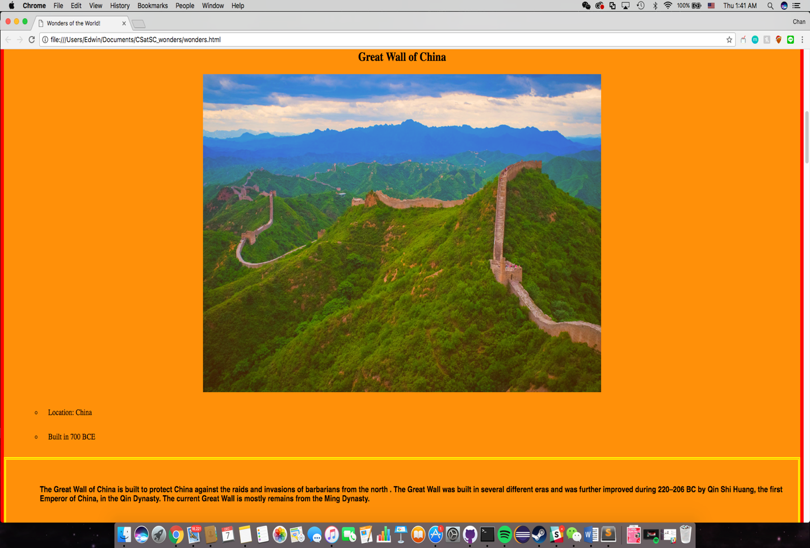

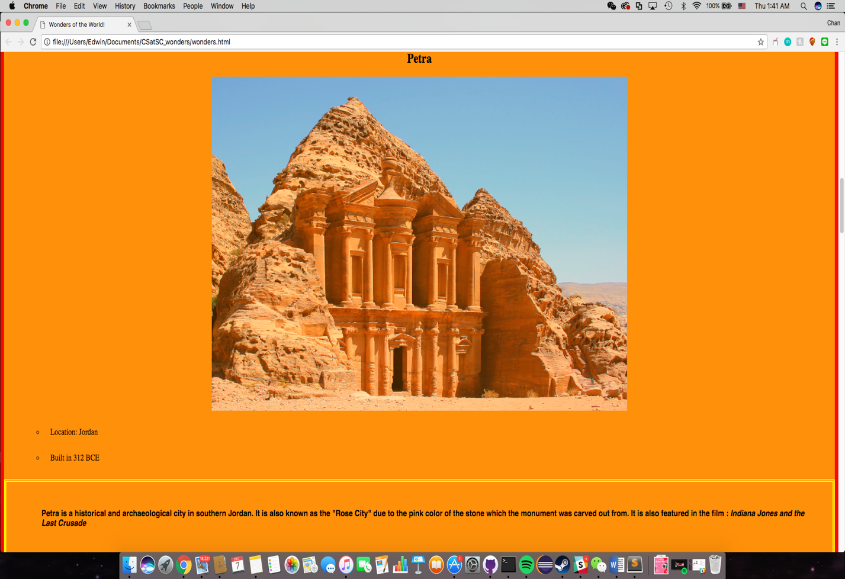

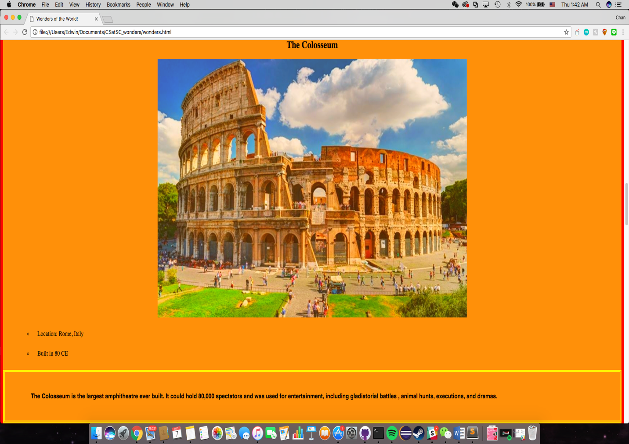

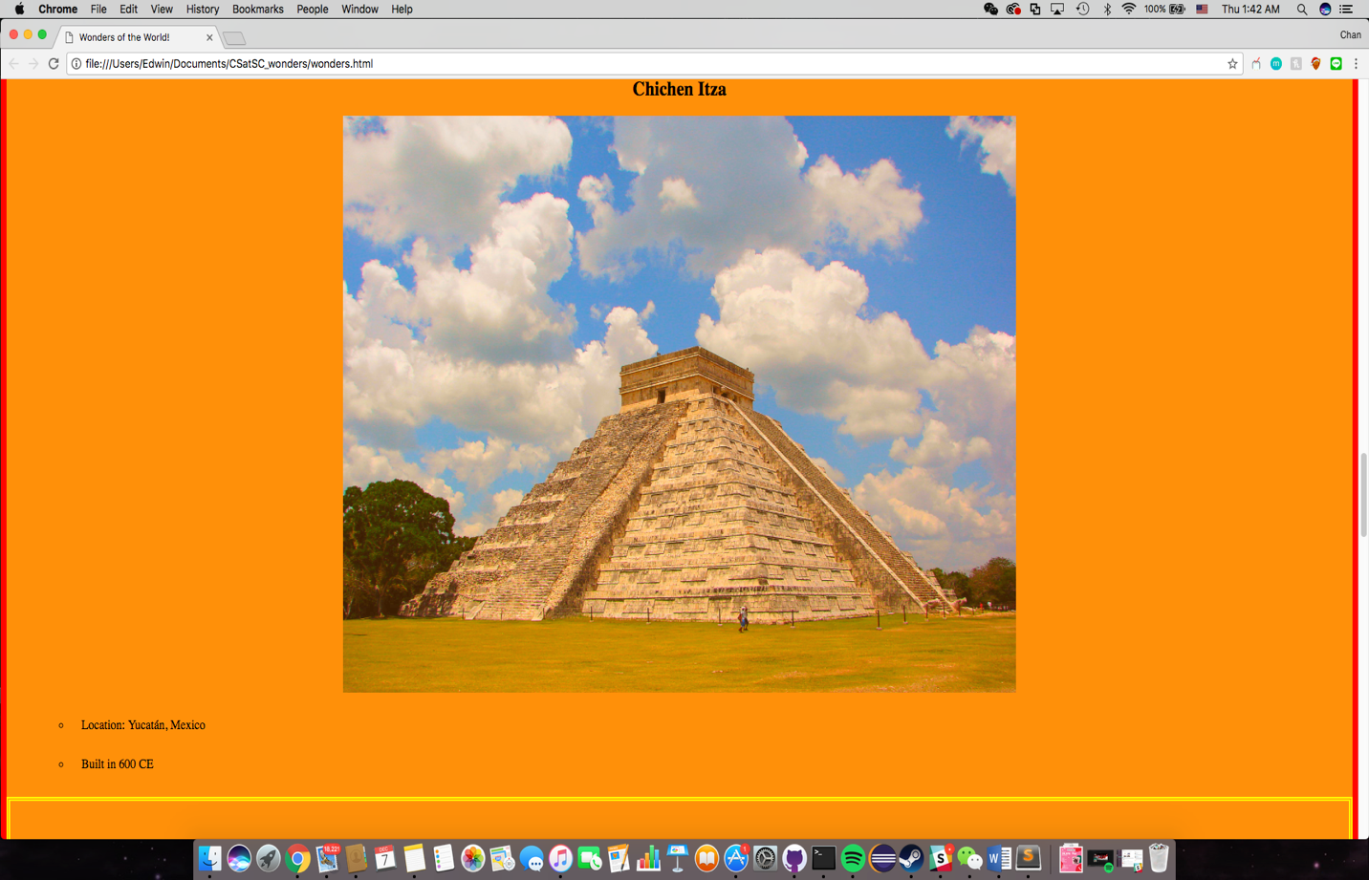

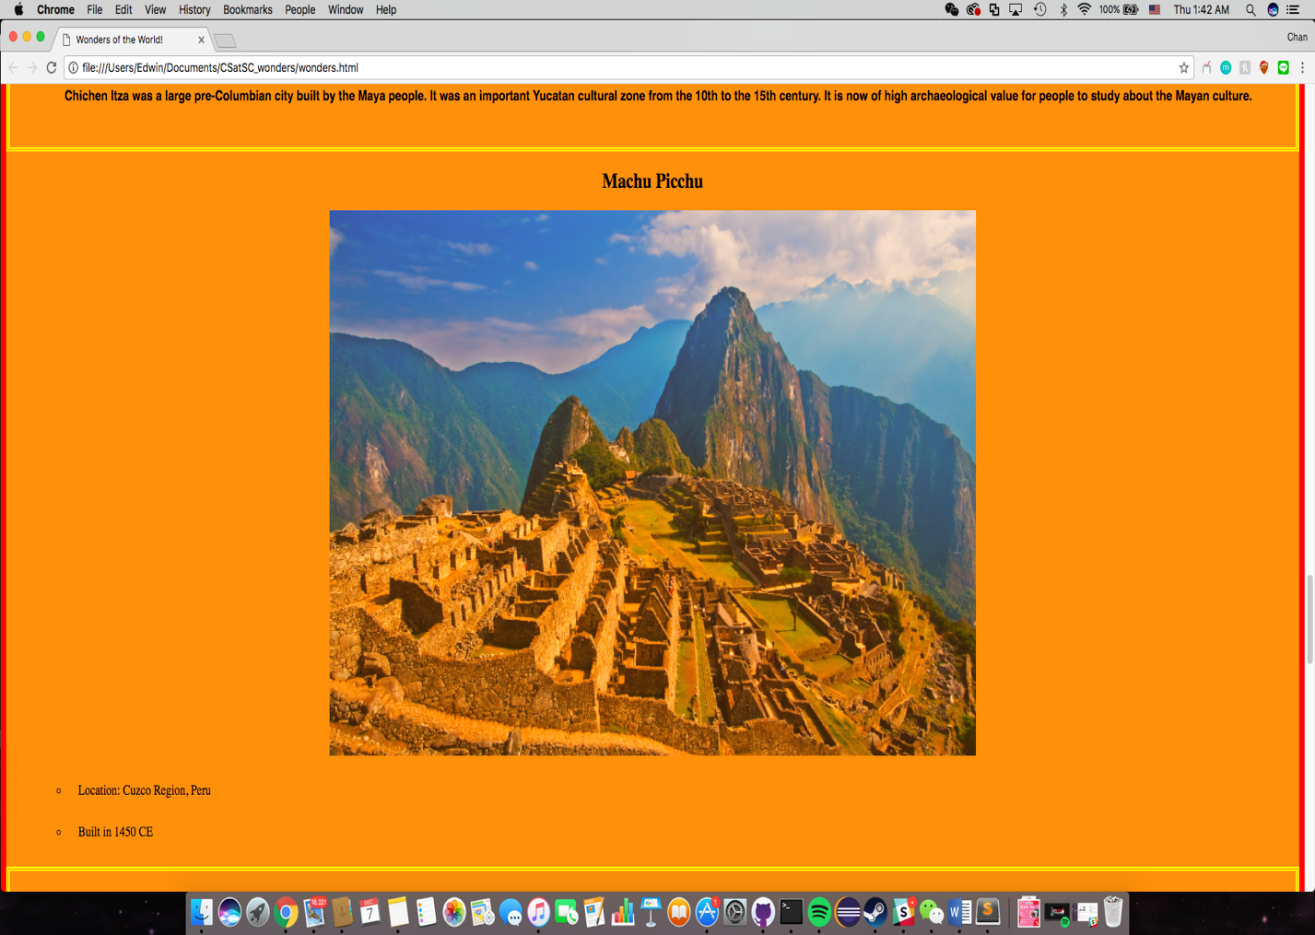

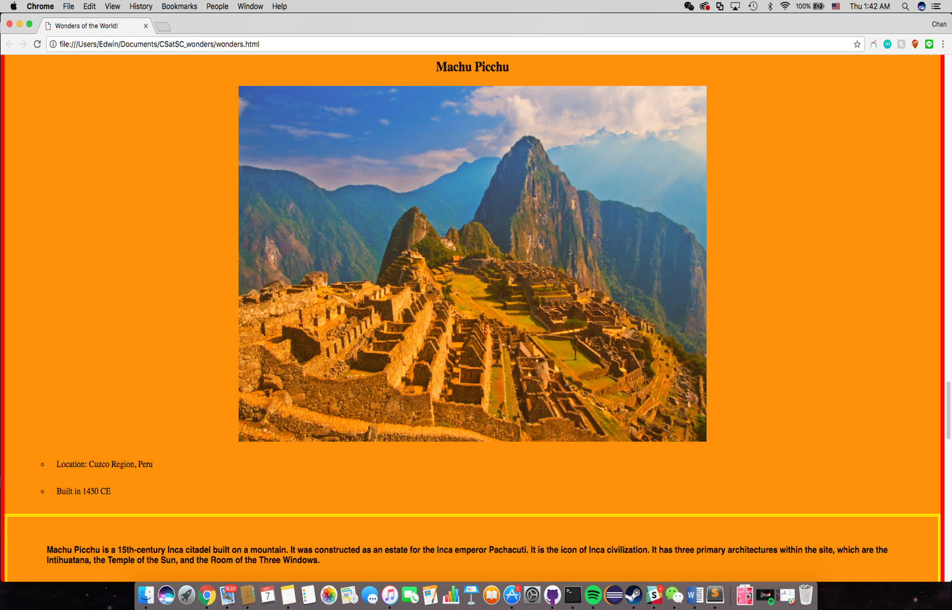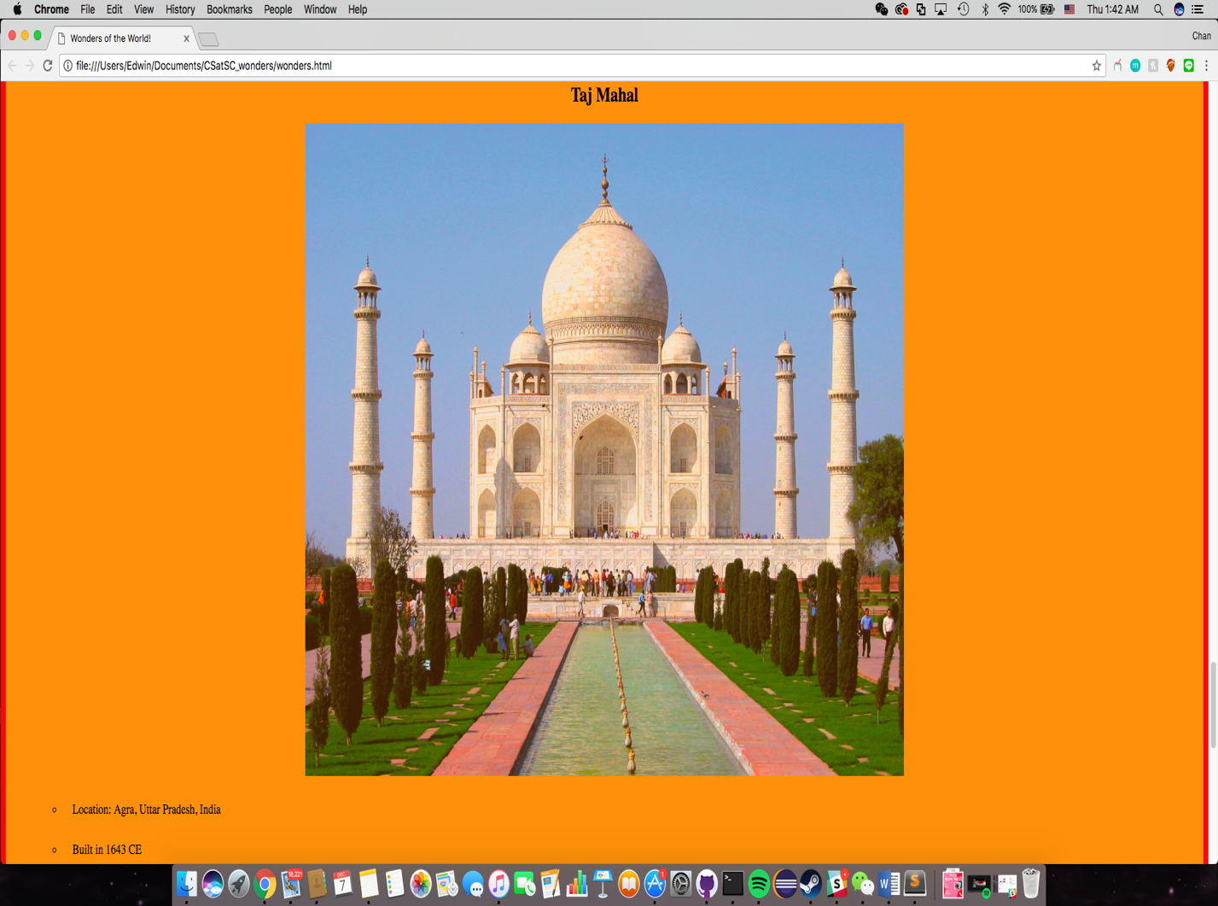

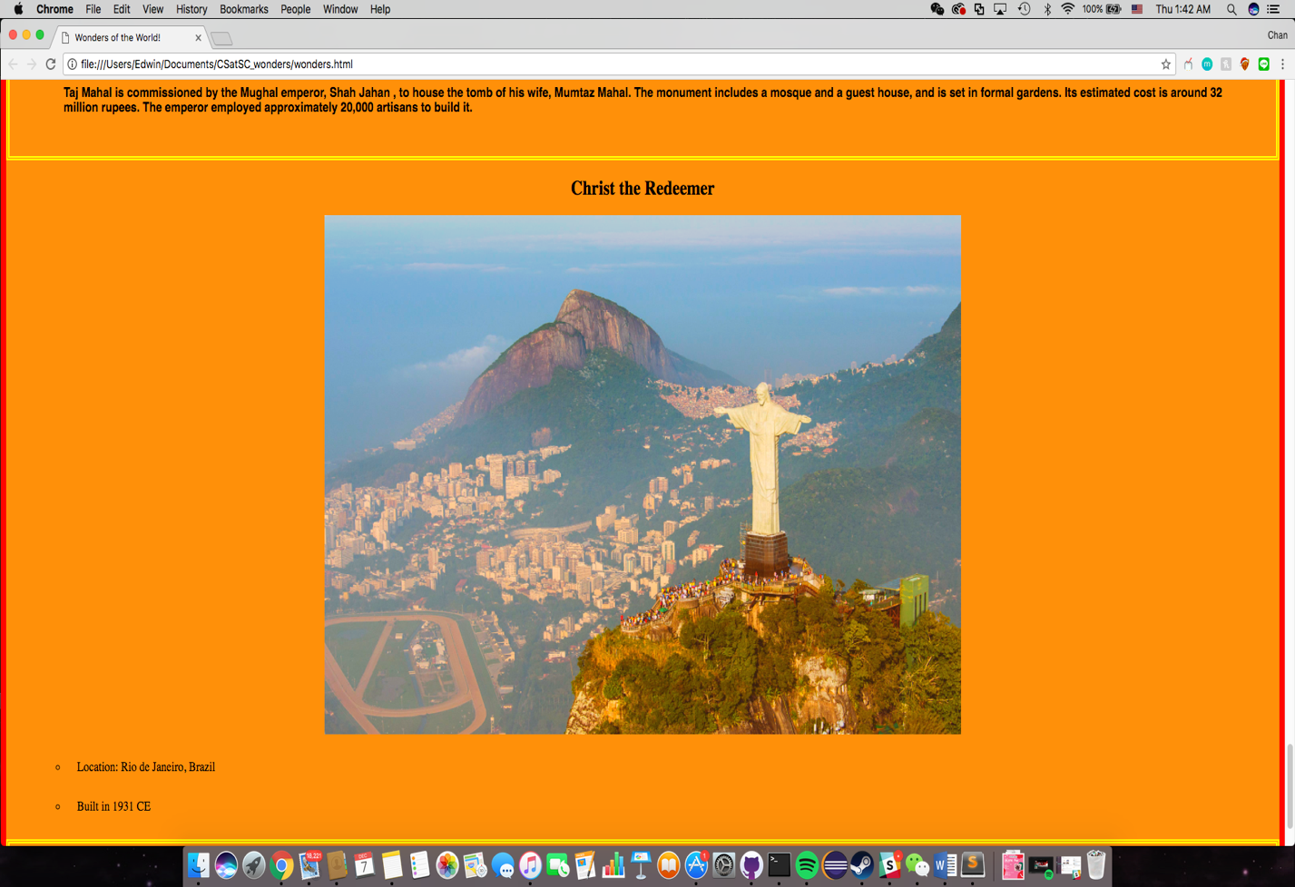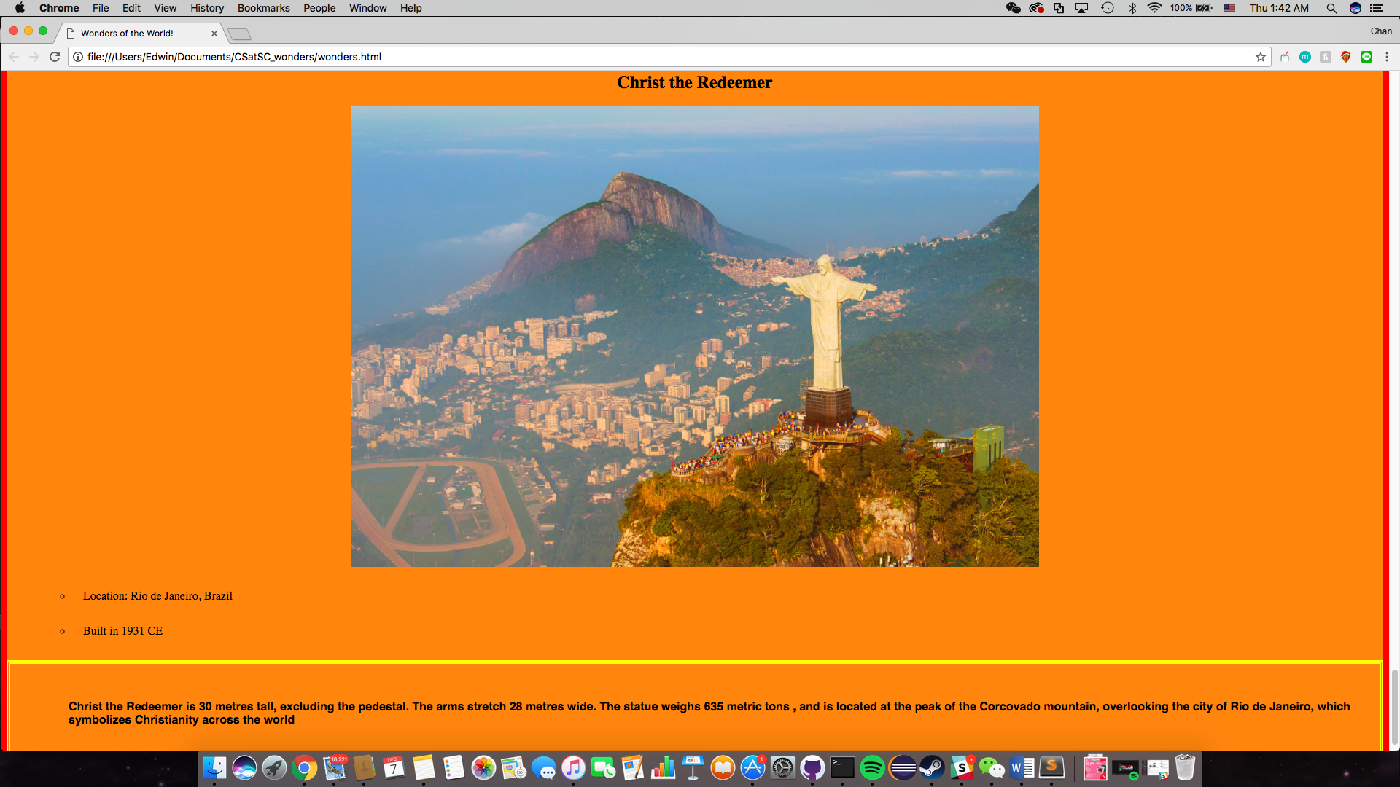**Solutions ( wonders.css)**

body {

background-color: #FF9009;

outline-style:solid;

outline-color:red;

outline-width: 10px;

}

h1 {

font-size: 40px;

text-align: center;

color: blue;

}

.intro{

font-size: 20px;

}

p {

font-family: sans-serif;

border-style: double;

border-width: 5px;

border-color: yellow;

padding-top: 50px;

padding-right: 30px;

padding-bottom: 50px;

padding-left: 80px;

font-weight: 900;

}

img{

display: block;

margin: auto;

opacity: 0.8;

-webkit-filter: saturate(2);

filter: saturate(2);

width: 50%;

}

.wonder{

text-align: center;

}

img:hover {

-webkit-transform: scaleX(-1);

transform: scaleX(-1);

}

li{

margin-left: 50px;

padding: 15px;

list-style-type: circle;

}

**wonders.html**

<html>

<head>

<title>Wonders of the World!</title>

<link rel = "stylesheet" type = "text/css" href = "wonders.css"/>

</head>

<body>

<h1>Wonders of the World!</h1>

<h3 class="intro"> There are so many wonders around the world that you <em>MUST VISIT</em> !! <br /> </h3>

<!-- Great Pyramid !-->

<h2 class="wonder"> Great Pyramid of Giza</h2>

<img src="pyramid.jpg" width="300" />

<ul type="disc">

<li> Location: Giza </li>

<li> Built in 2560 BCE </li>

</ul>

<p> The Great Pyramid of Giza is the oldest and largest of the three pyramids in the Giza pyramid complex. It is the only Seven Wonders of the Ancient World that survived till today.</p>

<!-- Great Wall of China !-->

<h2 class="wonder"> Great Wall of China </h2>

<img src="wall.jpg" width="300" />

<ul type="disc">

<li> Location: China </li>

<li> Built in 700 BCE </li>

</ul>

<p> The Great Wall of China is built to protect China against the raids and invasions of barbarians from the north . The Great Wall was built in several different eras and was further improved during 220–206 BC by Qin Shi Huang, the first Emperor of China, in the Qin Dynasty. The current Great Wall is mostly remains from the Ming Dynasty.</p>

<!-- Petra !-->

<h2 class="wonder"> Petra</h2>

<img src="petra.jpg" width="300" />

<ul type="disc">

<li> Location: Jordan</li>

<li> Built in 312 BCE </li>

</ul>

<p> Petra is a historical and archaeological city in southern Jordan. It is also known as the "Rose City" due to the pink color of the stone which the monument was carved out from. It is also featured in the film : <i>Indiana Jones and the Last Crusade</i></p>

<!-- Colosseum !-->

<h2 class="wonder"> The Colosseum</h2>

<img src="col.jpg" width="300" />

<ul type="disc">

<li> Location: Rome, Italy </li>

<li> Built in 80 CE </li>

</ul>

<p> The Colosseum is the largest amphitheatre ever built. It could hold 80,000 spectators and was used for entertainment, including gladiatorial battles , animal hunts, executions, and dramas.</p>

<!-- Chichen Itza !-->

<h2 class="wonder"> Chichen Itza</h2>

<img src="chichen.jpg" width="300" />

<ul type="disc">

<li> Location: Yucatán, Mexico </li>

<li> Built in 600 CE </li>

</ul>

<p> Chichen Itza was a large pre-Columbian city built by the Maya people. It was an important Yucatan cultural zone from the 10th to the 15th century. It is now of high archaeological value for people to study about the Mayan culture.</p>

<!-- Machu !-->

<h2 class="wonder"> Machu Picchu</h2>

<img src="machu.jpg" width="300" />

<ul type="disc">

<li> Location: Cuzco Region, Peru </li>

<li> Built in 1450 CE </li>

</ul>

<p> Machu Picchu is a 15th-century Inca citadel built on a mountain. It was constructed as an estate for the Inca emperor Pachacuti. It is the icon of Inca civilization. It has three primary architectures within the site, which are the Intihuatana, the Temple of the Sun, and the Room of the Three Windows. </p>

<!-- Taj!-->

<h2 class="wonder"> Taj Mahal</h2>

<img src="taj.jpg" width="300" />

<ul type="disc">

<li> Location: Agra, Uttar Pradesh, India </li>

<li> Built in 1643 CE </li>

</ul>

<p> Taj Mahal is commissioned by the Mughal emperor, Shah Jahan , to house the tomb of his wife, Mumtaz Mahal. The monument includes a mosque and a guest house, and is set in formal gardens. Its estimated cost is around 32 million rupees. The emperor employed approximately 20,000 artisans to build it.

</p>

<!-- Christ !-->

<h2 class="wonder"> Christ the Redeemer</h2>

<img src="christ.jpg" width="300" />

<ul type="disc">

<li> Location: Rio de Janeiro, Brazil </li>

<li> Built in 1931 CE </li>

</ul>

<p> Christ the Redeemer is 30 metres tall, excluding the pedestal. The arms stretch 28 metres wide. The statue weighs 635 metric tons , and is located at the peak of the Corcovado mountain, overlooking the city of Rio de Janeiro, which symbolizes Christianity across the world</p>

</body>

</html>